Institution’s Innovation Council IIC-CARE
REPORT ON
lly using the provided Word template.
Date & Time : 343242343423432 | VENUE : dfasdfdsafdsfsadfdas

The dawn crept slowly over the horizon, casting a soft, golden hue across the quiet, forgotten valley below.\nFor decades, this stretch of land had remained completely untouched by the bustling modern world, acting as a peaceful sanctuary for ancient oak trees, winding freshwater streams, and an incredible variety of wild animals.\nAs the early morning light filtered gently through the thick canopy of leaves, a cool breeze swept through the tall grass, carrying with it the fresh, crisp scent of pine and damp earth.\nIn the middle of a small, tranquil clearing, a solitary wooden cabin stood proudly against the elements, its weathered timber walls telling silent stories of past winters and countless forgotten seasons.\nSmoke curled lazily from the top of its stone chimney, drifting upward into the vast, cloudless blue sky and blending seamlessly with the morning mist.\nInside the cozy cabin, the faint, comforting sound of crackling firewood filled the small living room, creating an atmosphere of deep warmth and undeniable serenity.\nA heavy cast-iron kettle sat quietly atop the vintage wood-burning stove, gradually beginning to hiss as the water inside approached a gentle simmer.\nStepping out onto the rustic front porch with a warm mug in hand, one could look out across the rolling green hills stretching into the far distance and instantly feel an overwhelming sense of stillness.\nThere were no rushing crowds, no noisy traffic jams, and no endless notifications demanding immediate attention—just the simple, unhurried rhythm of the natural world unfolding as it always had.\nIt was the kind of extraordinary place where time seemed to slow down to a crawl, allowing a person to finally pause, draw in a deep breath, and quietly appreciate the quiet beauty of the present moment.
Poster:

Figure 1: Poster
Photos
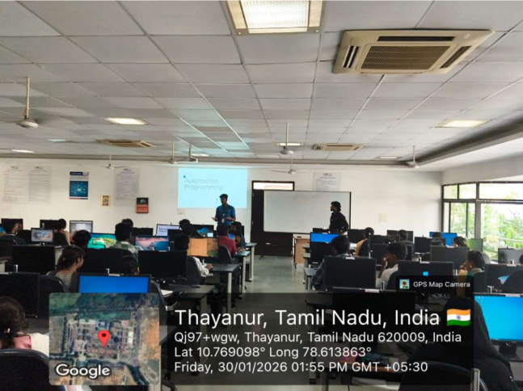
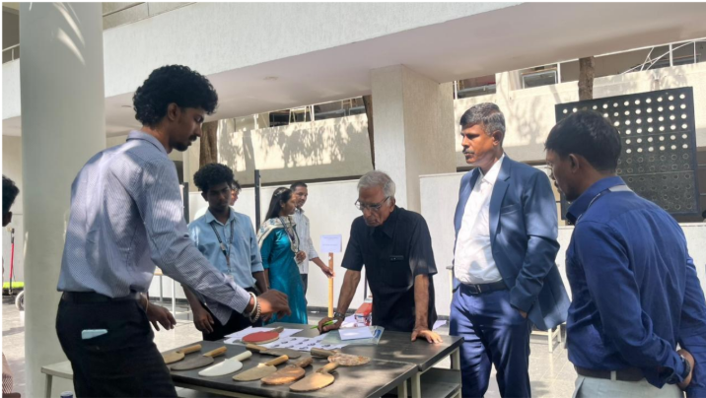

Principal



